# If/Else Statements

## Question: 1

Which of the following is an example of an if/else statement scenario?

If it is raining, bring an umbrella.

If it is cold out wear a coat. If it is raining, wear a hat.

If it is raining, bring an umbrella. If not, wear sunglasses.

If it is not cold out, don’t wear a coat.

## Question: 2

What is the limit of conditions that can be used in an if/else statement?

1

2

4

unlimited

## Question: 3

Which of the following if/else statements using a variable called ‘count’ are written correctly?

if count > 10():

forward(100)

else():

forward(50)

if count > 10:

forward(100)

else:

forward(50)

if (count) > 10:

forward(100)

else:

forward(50)

if count > 10:

forward(100)

else():

forward(50)

## Question: 4

What would be the radius of the circle output from the following code?

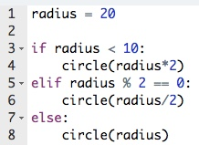

10 pixels

20 pixels

30 pixels

40 pixels